Name: ________________________________________________
Step 1: Create a design or shape that you will be able recreate (or at least approximate) with straight lines

Step 2: Plot points on the coordinate plane and draw straight lines between them to recreate your design
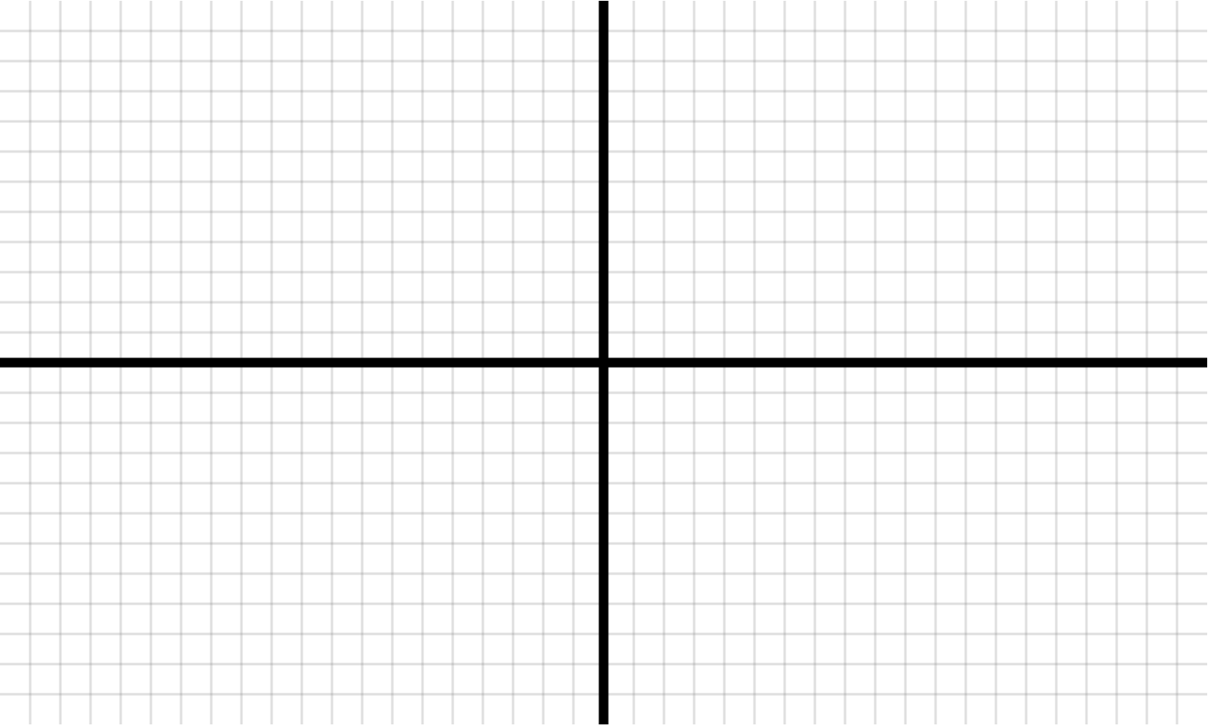
Name: ________________________________________________
Step 3: List the coordinate pairs you used in Step 2 in the order that they are connected. If you want to mirror them across the x-axis or the y-axis, write “Mirror across x-axis” or “Mirror across y-axis” for that step.
- ________ , ________
- ________ , ________
- ________ , ________
- ________ , ________
- ________ , ________
- ________ , ________
- ________ , ________
- ________ , ________
- ________ , ________
- ________ , ________
- ________ , ________
- ________ , ________
- ________ , ________
- ________ , ________
- ________ , ________
- ________ , ________
- ________ , ________
- ________ , ________
- ________ , ________
- ________ , ________
- ________ , ________
- ________ , ________
- ________ , ________
- ________ , ________
- ________ , ________
- ________ , ________
- ________ , ________
- ________ , ________
- ________ , ________
- ________ , ________
Step 4: Pass only this page to a partner (do not show them your design!) and have them plot and connect the pairs

