Name: ___________________________________________________________________ Period: _____________

You are going to create a comic strip that all about cell division. You will use abstraction to represent a complex scientific topic in a simple, artistic way. Your comic can be funny, colorful, artsy, whatever - but it’s important that you demonstrate to me and your reader that you understand cell division. Be sure to include scientific vocabulary and rich details!

Here are some examples to get your creative juices flowing. Your comic must include more scientific details!
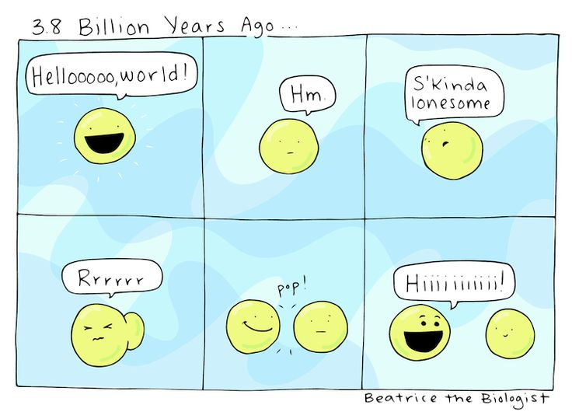
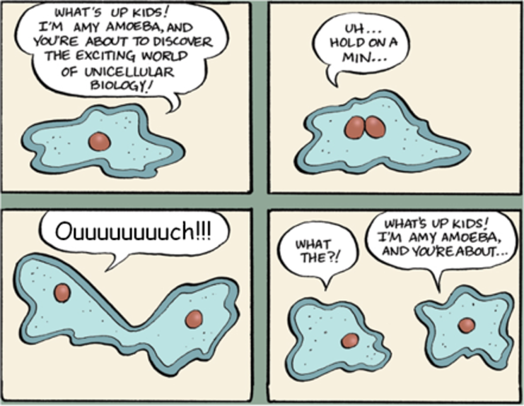
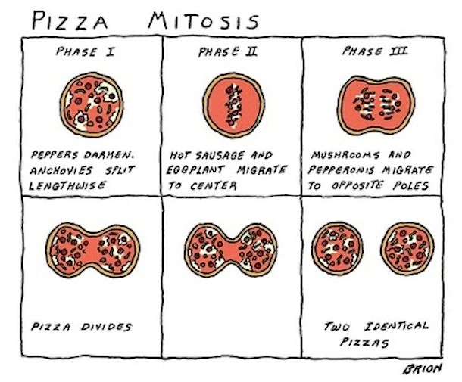
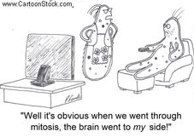

Sketch your idea!
Your comic can be one, three, four or six panels. You can create your final comic in Google Slides, or you can draw it by hand on paper.

Action: Sketch your idea here, using the same number of panels as your final comic.

Rubric

 | 10 | 8 | 5 | 0
Scientific Details | Many rich scientific details are included, demonstrating deep knowledge of cell division | Some scientific details are included, demonstrating knowledge of cell division | Few scientific details are included, demonstrating limited knowledge of cell division | No scientific details are included
Effort | Final comic is neat and very visually detailed | Final comic is mostly neat and somewhat visually detailed | Final comic is a little messy and not very visually detailed | Final comic is very messy and doesn’t include any visual details
Creativity | Comic is highly entertaining, using a great combination of cleverness, humor and artistic flourish | Comic is entertaining, using some cleverness, humor and/or artistic flourish | Comic is a little entertaining, using a bit of cleverness, humor or artistic flourish | Comic is not entertaining and does not use cleverness, humor or artistic flourish

